FULL STACK WEB DEVELOPMENT
LABORATORY RECORD — EXPERIMENT 02

1. BASIC INFORMATION
Experiment No. | 02
Date | 27/07/2026
Title | Design Webpage using HTML5 & CSS3
Application | My Styled Webpage with HTML5 Canvas
Course Outcome | CO1

2. AIM
To design an attractive webpage using HTML5 and CSS3, and to create basic graphical shapes using the HTML5 Canvas element and JavaScript.

3. OBJECTIVE
- Create a webpage using HTML5 structural elements.
- Use CSS3 properties to style the page background, header, navigation bar, cards, buttons, and footer.
- Create basic graphics using the HTML5 Canvas element.
- Draw a rectangle, circle, line, and text on the canvas using JavaScript.
- Apply borders, rounded corners, shadows, gradients, and hover effects.

4. THEORY
HTML5 provides the basic structure for webpages and includes elements such as header, nav, section, canvas, and footer. CSS3 is used to control the appearance of these elements. CSS3 supports properties such as background colors and gradients, padding, margins, borders, border-radius, box-shadow, and hover effects.
The HTML5 Canvas element provides a drawing area that can be controlled using JavaScript. The 2D context provides methods for drawing shapes and text. In this experiment, JavaScript is used to draw a rectangle, circle, line, and the text 'Sai Shishir' on the canvas.

5. SYSTEM REQUIREMENTS
Hardware | Software / Technology
Processor: Core i5 or equivalent  RAM: 8 GB or above  Storage: 10 GB free space | Windows 10/11  Visual Studio Code  Google Chrome / Microsoft Edge  HTML5, CSS3, JavaScript

6. PAGE DESIGN / STRUCTURE
The page contains a blue header titled 'My Styled Webpage', a dark navigation bar, a central HTML5 Canvas area, three styled content cards for HTML, CSS, and JavaScript, and a footer.
Header → Navigation → Canvas → Content Cards → Buttons → Footer

7. ALGORITHM / PROCEDURE
- Create an HTML5 document with the required head and body sections.
- Add a header containing the webpage title.
- Create navigation links for Home, About, and Contact.
- Add a canvas element with a suitable width and height.
- Create three content cards for HTML, CSS, and JavaScript.
- Use CSS3 to apply background colors, spacing, borders, rounded corners, and shadows.
- Add hover effects to the buttons.
- Use JavaScript to obtain the 2D canvas context.
- Draw a rectangle, circle, line, and text on the canvas.
- Add a footer with the designer name.
- Open the webpage in a browser and verify the final output.

8. SOURCE CODE
<!DOCTYPE html>
<html>
<head>
<title>My Styled Webpage</title>
<style>
body {
margin: 0;
font-family: Arial;
background: linear-gradient(lightblue, white);
}
header {
background: darkblue;
color: white;
text-align: center;
padding: 25px;
}
nav {
background: #333;
text-align: center;
padding: 10px;
}
nav a {
color: white;
text-decoration: none;
margin: 20px;
}
.canvas-box {
width: 470px;
margin: auto;
}
.card {
display: inline-block;
width: 230px;
padding: 20px;
margin: 20px;
background: white;
border: 2px solid gray;
border-radius: 15px;
box-shadow: 5px 5px 10px gray;
}
button {
background: green;
color: white;
border: none;
padding: 10px;
border-radius: 8px;
}
button:hover {
background: darkgreen;
}
footer {
background: black;
color: white;
text-align: center;
padding: 20px;
}
</style>
</head>
<body>
<header>
<h1>My Styled Webpage</h1>
</header>
<nav>
<a href="#">Home</a>
<a href="#">About</a>
<a href="#">Contact</a>
</nav>
<div class="canvas-box">
<canvas id="myCanvas" width="470" height="235"></canvas>
</div>
<div class="card">
<h2>HTML</h2>
<p>HTML is used to create webpages.</p>
<button>Read More</button>
</div>
<div class="card">
<h2>CSS</h2>
<p>CSS is used to style webpages.</p>
<button>Read More</button>
</div>
<div class="card">
<h2>JavaScript</h2>
<p>JavaScript makes webpages interactive.</p>
<button>Read More</button>
</div>
<footer>
Designed by Sai Shishir
</footer>
<script>
var canvas = document.getElementById("myCanvas");
var ctx = canvas.getContext("2d");
ctx.fillStyle = "blue";
ctx.fillRect(20, 20, 120, 70);
ctx.beginPath();
ctx.arc(210, 55, 38, 0, 2 * Math.PI);
ctx.stroke();
ctx.beginPath();
ctx.moveTo(285, 20);
ctx.lineTo(430, 120);
ctx.stroke();
ctx.font = "24px Arial";
ctx.fillStyle = "blue";
ctx.fillText("Sai Shishir", 145, 175);
</script>
</body>
</html>

9. CODE EXPLANATION
Code / Property | Purpose
<canvas> | Creates the drawing area.
getContext("2d") | Obtains the 2D drawing context.
fillRect() | Draws a filled rectangle.
arc() | Creates the path used for the circle.
moveTo() / lineTo() | Defines the points of the line.
fillText() | Displays text on the canvas.
linear-gradient() | Creates the light background gradient.
border-radius | Creates rounded card corners.
box-shadow | Adds shadow around the cards.
:hover | Changes the appearance when the pointer is over a button.

10. TEST CASES AND EXECUTION DATA
Test Case | Action / Input | Expected Result | Status
TC-01 | Open index.html in browser | Styled webpage is displayed | Pass
TC-02 | Observe the Canvas | Rectangle, circle, line, and text are displayed | Pass
TC-03 | Check content cards | HTML, CSS, and JavaScript cards are displayed | Pass
TC-04 | Move pointer over Read More button | Button hover effect is visible | Pass
TC-05 | Check footer | Designer name is displayed | Pass

11. EXECUTION STEPS
- Open the Experiment-02-HTML5-CSS3 folder in Visual Studio Code.
- Open the HTML file from the src folder.
- Save the file.
- Open index.html in Google Chrome or Microsoft Edge.
- Verify the header, navigation bar, Canvas drawing, three content cards, buttons, and footer.
- Move the pointer over the buttons to verify the hover effect.
- Capture the final webpage output.

12. OUTPUT
The actual output below shows the completed styled webpage. The header, navigation bar, Canvas drawings, HTML/CSS/JavaScript cards, buttons, and footer are visible.
Figure 1: HTML5 Canvas and CSS3 Styled Webpage — Actual Output
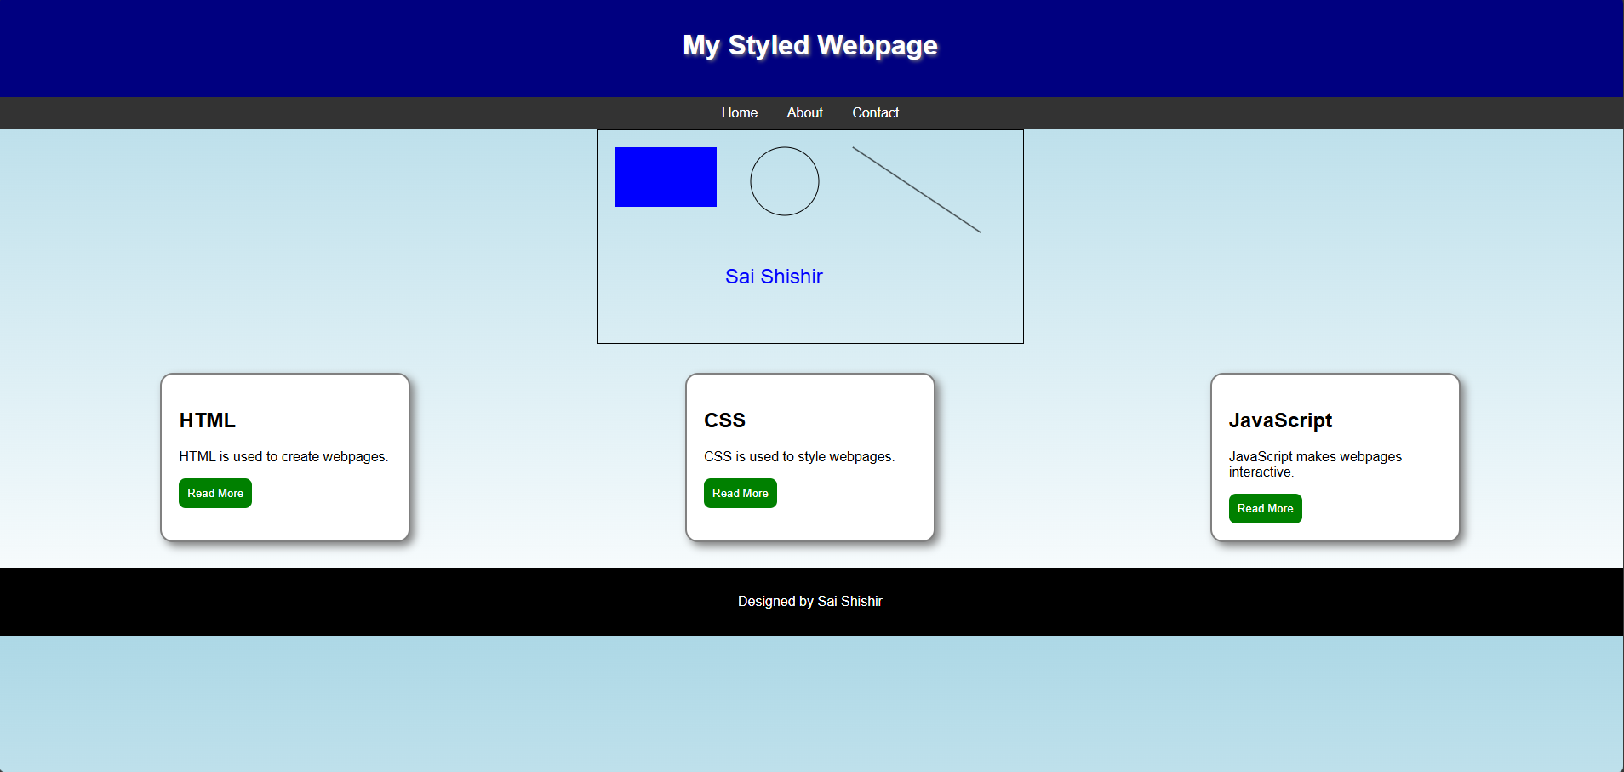

13. RESULT / CONCLUSION
The webpage was successfully designed using HTML5 and CSS3. HTML5 Canvas and JavaScript were used to create basic graphics, while CSS3 properties were used to produce the styled layout, cards, buttons, background, and footer.

14. PRECAUTIONS
- Ensure that the Canvas ID in JavaScript matches the ID in HTML.
- Use valid CSS property names and values.
- Save the webpage before refreshing the browser.
- Check that all HTML tags are properly closed.
- Verify the JavaScript drawing code if the Canvas output is not displayed.
- Test the hover effect in a modern browser.

15. VIVA-VOCE QUESTIONS
1. What is HTML5 Canvas?
It is an HTML5 element used as a drawing area for graphics.
2. What does getContext("2d") do?
It provides the 2D drawing context for the Canvas.
3. Which method is used to draw a rectangle?
fillRect() is used to draw a filled rectangle.
4. What is the use of CSS3?
CSS3 is used to style and control the appearance of webpages.
5. What is border-radius?
It is used to create rounded corners.
6. What is box-shadow?
It adds a shadow effect around an element.

